Sangala Studio
User Guide
A Digital Fabrication tool for the classroom
Version 6.2
Table of Contents
1. Workflow for Creating a Collage 1
2. Getting started 2
3. Cut lines and fold lines 3
4. Importing and tracing a photo 4
5. Drawing shapes 5
6. Editing shapes 6
7. Drawing with Snap! 7
8. Combining shapes 10
9. Aligning shapes 10
10. Mirroring shapes 11
11. Examining Fine Detail 11
12. Cutting Out a Design 11
13. Saving the Design 12
14. Designing in 3D 13
Switching to 3D 13
Giving a shape depth 13
Sloping a top 14
The Brick tool 15
Previewing in 3D 15
Marking a Shape as a Hole 16
3D bars 17
Grouping pieces 17
Combining in 3D 18
Seeing a hole before you combine 18
Building a curved, tapering part 18
Saving for the printer 19
15. Quick Reference 20
16. Tool Sequences for Specific Designs 21

Sangala Studio User Guide
Sangala Studio is a Digital Fabrication tool developed to support the course, Introduction to Design through Making. The word "sangala" means joy in the Lugisu language spoken in the Mt. Elgon region in East Africa. A version of this course focused on exploring art and engineering is being developed to support a collaboration with East Africa. A book, Design through Making: Art and Engineering, has also been developed to support this special version of the course. It focuses on a sequence of activities that move from two-dimensional art to three-dimensional design and then incorporate animated and automated mechanisms.
These activities have been developed over sixteen years. They began in 2010 with the construction of the Laboratory School for Advanced Manufacturing, a joint project of the Charlottesville City School System and the University of Virginia, led by the faculty and staff of the Make to Learn Laboratory. They continue to be developed through a collaboration between the University of Virginia and REACH for Uganda, anchored by EDIS 3050 at the University of Virginia and a pilot course at Hawthorne-Scribner High School.
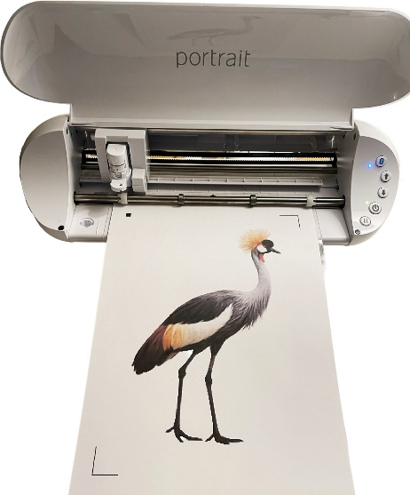
Figure 1. Using Sangala Studio and a Silhouette die cutter to cut out the silhouette of a crested crane.
The Sangala Studio digital fabrication tool supports the design activities in the 2D design portion of the course covered in Chapters 1 through 3 of the accompanying book. These activities include development of a collage that is used as scaffolding to create a shadowbox. A shape designed in Sangala Studio is fabricated on a digital die cutter. This guide covers the 2D features needed for these projects: importing and tracing a photo, drawing and combining shapes, and doing a print-and-cut. The final section introduces the three-dimensional design mode, which is used later in the course for objects made on a 3D printer.

1. Workflow for Creating a Collage
To make a collage, the workflow follows this sequence using Sangala Studio:
- Identify an image.
- Import the image into Sangala Studio.
- Remove the background.
- Use the outline of the image as the template for an object in the collage.
- Send the outline to the digital die cutter to cut out the shape from cardstock.
The pieces can be cut one at a time from colored cardstock, as in step 5 above. They can also be finished together: give each piece a paper color, arrange them on the page, and print the whole collage in color on a single sheet of white cardstock. The die cutter then cuts every piece out in one pass (Section 11).
The following sections describe the tools in Sangala Studio used to fabricate the collage.

2. Getting started
Sangala Studio runs in a web browser and controls the die cutter — the machine that cuts a shape by tracing its outline with a small blade. The window has three parts:
- The mat in the center of the Sangala Studio workspace is the large white rectangle. It represents the sticky carrier sheet — the physical sheet that holds the paper flat and carries it through the die cutter. Cardstock or paper placed on the mat is what the machine will cut.
- The Tools Palette runs down the left edge. Each button is one tool for drawing or editing shapes.
- The Fabricate Panel on the right holds the green Make It! button, short status messages, and — whenever a shape is selected — a panel for changing that shape.
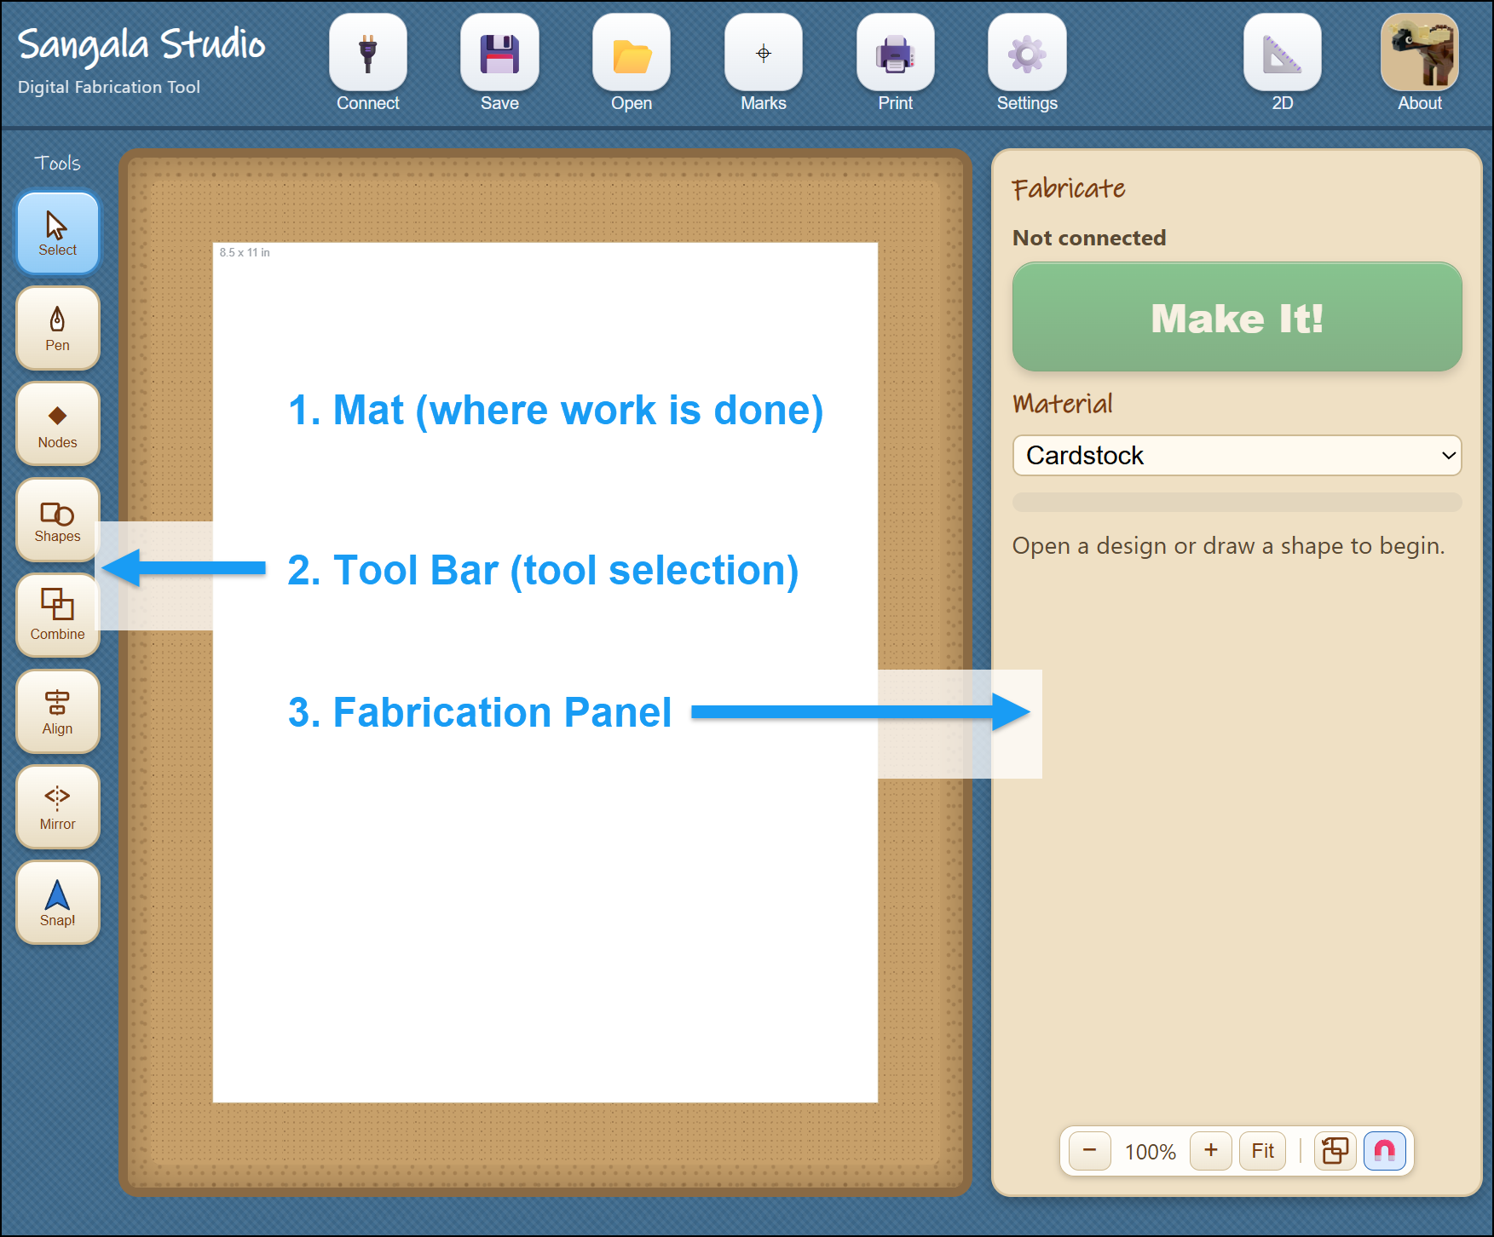
Figure 2. The Sangala Studio window, with the Mat (1) labeled in the center,
the Tools Palette (2) on the left, and the Fabricate Panel (3) on the right.
To use the die cutter, first connect to it:
- Plug the die cutter into the computer with its USB cable and turn it on.
- Click the Connect icon at the top left.
- When the status in the Fabricate Panel changes from "Not connected" to the machine's name (Silhouette Portrait 3 in this instance), Sangala Studio is ready to fabricate shapes.
A design can be made at any time; a connection to the die cutter is only needed to cut out a shape.
The top row also carries the controls for keeping a design. The Save button (the disk icon) sits between Connect and Open, and clicking it opens a small menu with two choices — Save as SVG and Save project, described in Section 13. In 3D mode an Export STL button (the blue diamond) appears on this same row for saving a model to print; it stays hidden while a design is being cut out.

3. Cut lines and fold lines
The die cutter treats a line in one of two ways, and it cannot tell them apart on its own, so each line must be marked. There are three kinds:
- Cut Lines — the blade cuts all the way through the cardstock. A cut line is a solid red line.
- Fold Lines — The die cutter makes a series of dashed cuts to create a crease (fold line) so that the cardstock folds cleanly along it. A fold line is a dashed blue line.
- Print Only — Shapes and images can be printed on an inkjet printer. This is used for artwork or shapes.
In the illustration below (Figure 3), a calibration card developed as a test file is shown with a cut line (a solid red line) around the perimeter of the card and a fold line (shown as a dashed blue line) in the center of the card.
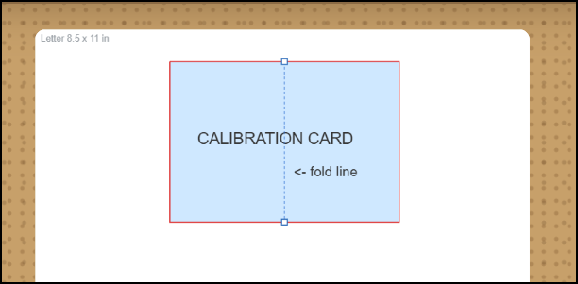
Figure 3. A cut line is shown in red while a fold line (in the center) is a dashed blue line.
The die cutting machine will create dashed scores in the center of the card so that it can be folded and will cut out the card from the cardstock using the solid red line as a guide that determines the path of the cutting blade.

4. Importing and tracing a photo
Sangala Studio can turn a photograph into a silhouette — the solid outline of a subject with all its inner detail removed, such as the shape of a crowned crane standing black against the page.
- Click Open (the Folder Icon) and choose a photograph (a .png or .jpg file). It appears on the mat as a reference layer.
- Click Remove BG (the Wand Icon). Sangala Studio attempts to find the main subject in the foreground. It then draws a red line around the outline of the object. This outline is the path that the blade will follow to cut out the silhouette of the object.
- Use the two sliders that appear in the Fabricate Panel to make adjustments:
  - Silhouette Threshold makes the outline tighter or looser.
  - Ignore Specks removes small stray bits so that only the main subject is outlined.
- Click Confirm. Sangala Studio removes the background outside of the red cut line, leaving the subject and the red path the blade will follow around it.
- There are two options at this point:
    - To simply create a silhouette of the object from colored cardstock,
      - Place the cardstock on the carrier sheet and load it into the die cutter.
      - Then click the Make It! button on the Fabricate Panel to cut out the silhouette.
    - To print the image and cut it out of the printed card stock:
      - First turn registration Marks on. Three marks appear on the page; the die cutter reads them to line the blade up with the printed picture.
      - Then click Print to send the image (with registration marks) to print the picture on an inkjet printer.
      - Next place the printed cardstock on the carrier sheet and load it into the die cutter.
      - Finally, click the Make It! button on the Fabricate Panel to cut out the image.
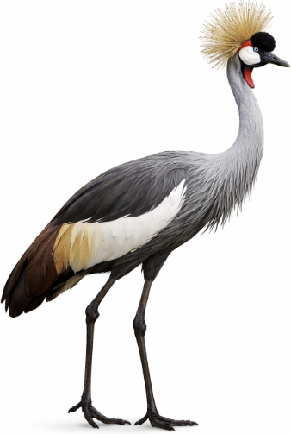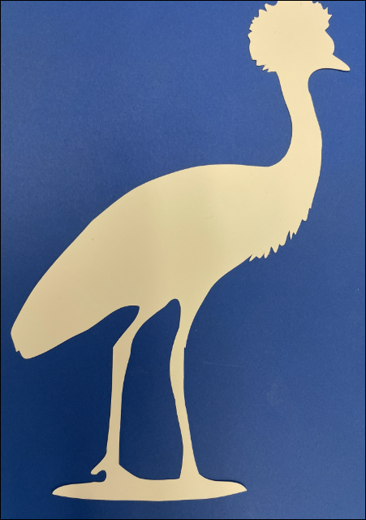
Figure 4. A photograph of a crane (left) and its silhouette cut out of cardstock (right).

5. Drawing shapes
Not every shape comes from a photo. Two tools draw shapes directly.
The Shapes tool (the rectangle-and-circle icon) opens a small menu:
- Click Shapes, then choose Line, Rectangle, or Circle.
- Drag the cursor across the mat. A rectangle grows from corner to corner; a circle grows from its center outward.
A line runs straight from where the drag starts to where it ends. Hold Shift to keep it level, upright, or at 45 degrees. A line is a Cut line at first — it slits the paper; click Fold to make it a crease instead.
- Release the mouse button to create a shape.
Note: To set an exact size, select the shape and type its measurements in the Selected Object panel (Section 6).
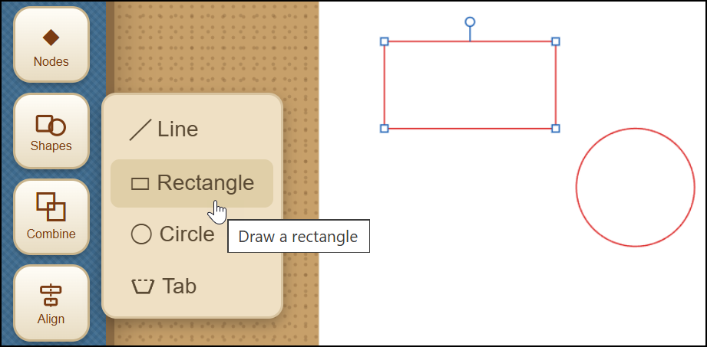
Figure 5. The Shapes menu (Line, Rectangle, Circle, Tab) and shapes drawn on the Mat workspace.
The Tab tool (also in the Shapes menu) adds a glue tab — the small flap that folds back and is glued when a flat design is assembled into a box or model:
- Click Shapes, then choose Tab.
- Press on the edge of a shape and drag along it. The stretch covered becomes the fold hinge, and a preview of the tab follows the drag.
- Release, and the tab is built: three cut sides, a fold hinge on the edge — and the shape's own edge beneath the hinge is removed automatically, so the tab stays attached instead of being cut off.
The tab's size is chosen automatically from the length of the hinge. Its pieces are grouped so the tab moves as one; use Ungroup to adjust a side by hand.
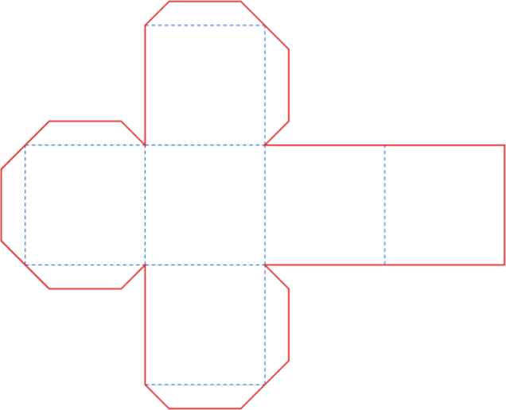
Figure 6. A box with cut lines, fold lines, and glue tabs.
The Pen tool (the pen-nib icon) draws a free-form outline point by point — useful for a custom shape such as a mountain profile:
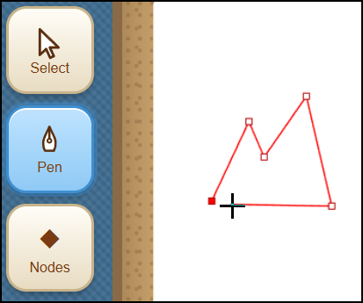
Figure 7. The Pen tool (used to draw a mountain profile in this example).
- Select the Pen icon in the Tools menu.
- Click on the mat to place each corner point. A red line follows the cursor to preview the next segment.
- To close the shape, click the first point again or press Enter.
If a point lands in the wrong place, Ctrl-Z takes it back — one point at a time — and Ctrl-Y puts it back. Pressing Esc, or choosing another tool, leaves the Pen and keeps the outline as it stands: an unfinished outline stays on the mat as an open line rather than being discarded, so nothing is lost by stepping away in the middle of one. Ctrl-Z removes the outline if it is not wanted after all.
The Pen can also carry on from an outline that is already on the mat. Wherever an outline has a loose end — after Break at Node, for example — the end fills in as the Pen approaches it. Click the end and the Pen continues from there; click the outline's other end to close the shape, or press Enter to leave it open. This is how a traced silhouette is opened, extended, and closed again to make a region that can be given a paper color, such as the foliage of a tree.

6. Editing shapes
Selecting a shape with the Select tool (the arrow) opens the Selected object panel on the right, which is where a shape is measured and changed. A shape that has been given a paper color can be selected by clicking anywhere inside it; a shape that is only an outline is selected by clicking on its outline. Moving an outline-only shape no longer means hunting for that thin line, though: press anywhere inside the shape and begin to drag, and its whole interior acts as a grip that picks the shape up and moves it in one motion.
- Move or resize — drag the middle of a shape to move it, or a square handle to resize it. An imported design, or several shapes selected together, shows a dashed box: its corners resize without changing the proportions, its sides stretch one way only. A line, or a 3D bar, has no interior middle to press; grab it near its stroke instead — the same short reach a click uses — and drag it to move it, just as with a shape.
- Nudge — with a shape selected, the arrow keys move it 0.1 mm at a time; hold Shift for 1 mm steps — a precise final adjustment after a shape has been dragged close with the mouse.
- Rotate — drag the round handle that appears above a selected shape; hold Shift to snap to fifteen-degree steps. Rotating a rectangle converts it into an editable outline. The same handle appears above a Tab, a Group, or several shapes selected together, and turns all of them as one around their shared center.
- Set the line type — click Cut, Fold, or Print Only to set the line type that determines what the die cutter does with that shape (Section 3 above). The highlighted button is the current setting.
- Paper color — give a shape the color of the card it will be cut from, so the mat shows the finished collage instead of a tangle of outlines. Choose one of the colors in the Selected object panel, or the color wheel at the end of the row for any other. The color is never cut, so the die cutter still follows the outline. It does now print, though: with registration Marks on, every colored piece prints in its color on one sheet, ready to cut out together (Section 11).
- Layer — where shapes overlap, the one drawn most recently sits in front. Back, Lower, Raise and Front change that order, so the sky can be moved behind the grass. On the keyboard, Page Down and Page Up move a shape one step, and End and Home send it to the back or bring it to the front.
- Exact size and position — the panel shows the measurements in a small box; click a number and type to set an exact value.
- Simplify the outline — an outline is made of nodes (the points where the line changes direction). Fewer nodes cut more smoothly. Simplify nodes reduces the count while keeping the shape; the Nodes tool (the diamond icon) lets individual points be dragged, added, or deleted.
- Delete — click the Delete button, or press the Delete key on the computer keyboard.
- Undo and redo — Ctrl-Z undoes the last change; Ctrl-Y (or Ctrl-Shift-Z) redoes it.
- Duplicate — Ctrl-C copies the selected shape and Ctrl-V pastes a copy beside it, complete with its line type and settings. Paste again for more copies.
- Break at a node — with the Nodes tool, click a node and press Break at Node. A closed shape opens there; an open line splits into two pieces. Each piece can then be Cut, Fold, or deleted on its own — three sides Cut and one side Fold makes a glue tab by hand.
- Snap to Fit — when a shape is dragged near another, their corners pull together and lock exactly; a green dot marks the shared point. The magnet button beside the zoom controls turns this off, and holding Alt while dragging moves a shape freely.
To work on several shapes at once, drag a box around them . They can then be moved, deleted, or changed to Cut, Fold, or Print together. Each selected shape is marked by a faint gray panel behind it.
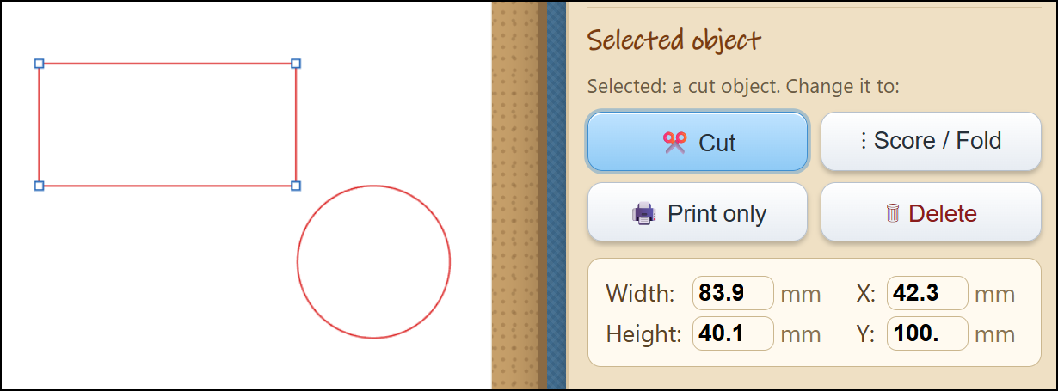
Figure 8. The Selected Object panel that is used to set the line type (Cut, Fold, Print)
and enter exact specifications for the size and position of the shape.

7. Drawing with Snap!
Snap! is a block programming language in which a turtle draws by moving across the screen — the turtle graphics that have been used in classrooms for many years. Sangala Studio can take what the turtle drew and cut it, crease it, or draw it on paper. A Snap! program therefore becomes a design, and an existing turtle program becomes one simply by choosing the color of its pen.
1. Open Snap! — Select the Snap! icon in the Tools palette. Snap! opens a window of its own. Launch Snap! using this button: a drawing can only be imported to Sangala Studio through a Snap! window that Sangala Studio itself has opened.
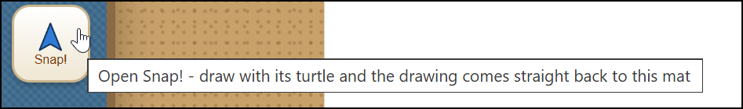
Figure 9. The Snap! button in the Tools Palette opens Snap! in a separate window.
- Import the Sangala Blocks Library (first time only) — In Snap!, choose File, then Import, and select the file labeled “Sangala for Snap.xml”. Three blocks will appear in a new palette in the Snap! Blocks Categories.
- Enable JavaScript — In Snap!'s settings menu (gear icon), check the JavaScript extensions box.

- Build the script — Place the Record Turtle Paths block at the top of the drawing script, above pen down, and then place Send Paths to Sangala Studio the at the bottom of the script.
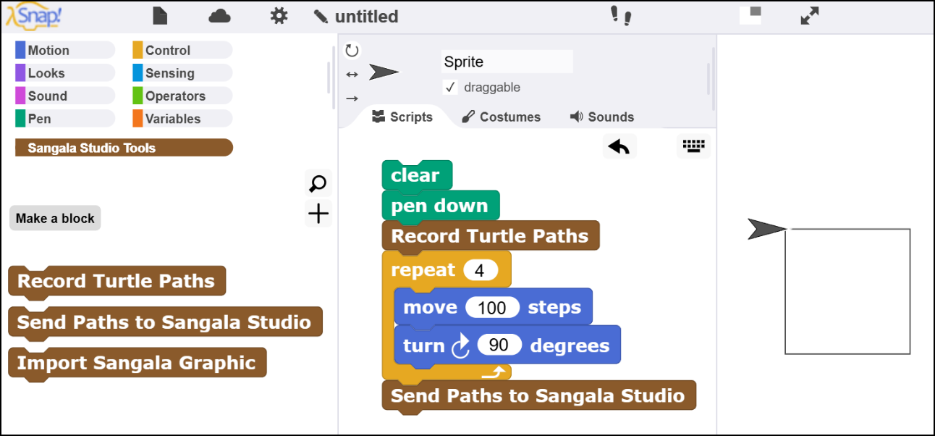z
Figure 10. The two Sangala blocks in Snap! (left), a script that draws a square
(center), and the square the turtle has drawn on the Snap! stage (right).
4. Send the Drawing — When you run the script in Snap!, it will send the drawing created by the Snap! turtle (the triangle that draws the lines) to Sangala Studio.
5. Choose what the Die Cutter will do — The drawing appears in the middle of the workspace in Sangala Studio, where it can be moved, reshaped with the Nodes tool, or combined with other shapes like any other design.
The pen color determines the actions of the die cutter. A red line instructs the die cutter to cut out the shape. A blue line is interpreted as a fold line (consisting of a series of dashed cuts). Other lines are interpreted as drawn lines. The actions of each line can also be set or changed in the Sanagala Studio Selected Objects panel.
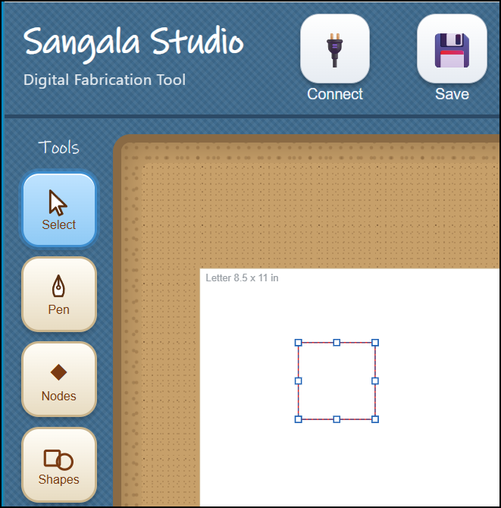
Figure 11. The design created in Snap! will appear in the Sangala Studio workspace.
To draw rather than cut, put a pen in the tool holder, choose Pen (draw) as the material in Setup, and press Make It! The die cutter draws the turtle's path at full size on paper. To cut the design out instead, put the blade back in and choose the material being cut. A drawing that mixes red and blue lines becomes a paper-craft net, in which the red lines are cut and the blue lines are creased ready to be folded.
One hundred turtle steps arrive as about 26 mm, so a drawing that fills Snap!'s stage is roughly the width of a sheet of paper. A design too large for the page can be reduced with Scale in the Setup panel.
Sangala Studio can also send a design the other way — onto the Snap! stage, where a Snap! program can use it as the costume for a sprite. This is a way to make artwork for a program, such as the dials and buttons of a dashboard, by drawing it rather than writing code for it.
1. Choose the design — draw or select the shapes in Sangala Studio. If nothing is selected, the whole mat is sent.
2. Bring it across — in Snap!, click the Import Sangala Graphic block. The design appears on the Snap! stage as a black outline. (Snap! must have been opened from the Snap! icon in Sangala Studio – as described above – so that the two applications will be able to communicate with one another.)
3. Make the Imported Graphic a Costume — Hold the Shift key and right-click the stage, then choose pen trails from the menu. A new costume will appears in the sprite's costume library.
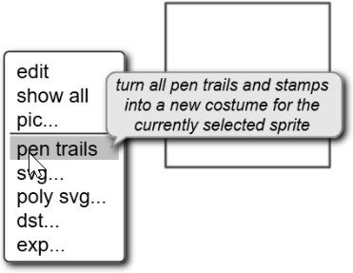
Figure 12. An imported design can be used to
create a costume for the current Snap! sprite
4. Add color — open the costume in Snap!'s paint editor and fill the enclosed areas with color.
The design crosses in black and white; color is added in Snap!. The outline itself stays in Sangala Studio, so the same design can also be cut or folded.

8. Combining shapes
The Combine tool (the overlapping-squares icon) joins two shapes. Select one shape, then hold down the Shift key and select a second shape (which will then be highlighted in orange). Then choose:
- Union — join both shapes into one outline.
- Difference — remove the second (orange) shape from the first.
- Intersect — keep only the part where the two shapes overlap.
Difference and Intersect keep any windows a shape already has, so a second, third, and further window can be cut into the same shape — disjoint windows stay separate, and overlapping ones merge into one. This is what lets a single frame carry several openings. Combine also handles shapes built from touching or overlapping rectangles, and concave L- or U-shaped slots, without mangling the outline.
In 3D mode the Combine menu offers only Union and Intersect; Difference is not shown, because carving in 3D is done a different way — mark a shape as a Hole (it draws as a blue dotted outline) and then Union it, and the hole subtracts a void instead of adding material. Any number of shapes can be selected and combined at once, not just two, and Union honors each shape’s Solid/Hole setting, so solids merge while holes carve in a single step. The 3D side of Combine, which bakes the result into one printable part, is described in Section 14.
To place a photo inside a circle (or any outline) for a collage: open the photo, draw a shape over the part to keep, click the shape, then hold Shift and click the photo, and choose Intersect. Everything outside the shape is removed, leaving a print-and-cut of the cropped photo.
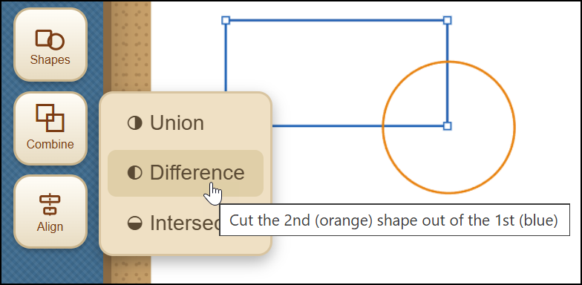
Figure 13. Using the Combine option to combine two overlapping shapes.

9. Aligning shapes
The Align tool (the centered-bars icon) lines shapes up. Select two or more shapes — draw a box around them, or click one and Shift-click another — then choose:
- Vertical — the shapes line up vertically.
- Horizontal — the shapes line up horizontally.
- Center — the shapes are centered on one another.
The largest shape stays in place and the others move to it, so Center drops a small circle exactly into the middle of a square frame.
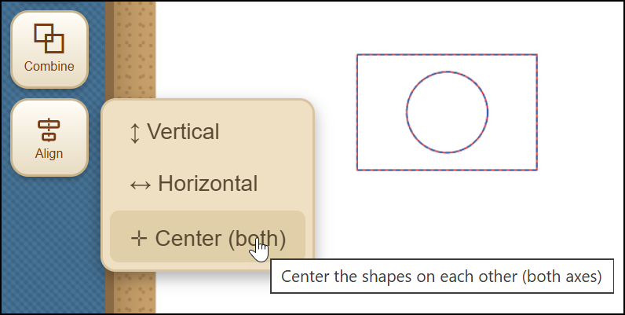
Figure 14. Using the Align option to center two shapes.

10. Mirroring shapes
The Mirror tool (the two arrows facing a dashed line) flips a selection over, so a part made for one side of a design becomes the matching part for the other. Select one or more shapes — draw a box around them, or click one and Shift-click another — then choose:
- Flip Horizontal — the selection is reversed left to right.
- Flip Vertical — the selection is reversed top to bottom.
The flip happens about the middle of whatever is selected, so the shapes stay where they are on the mat instead of jumping to one side.
Mirroring a single rectangle or circle looks as though it does nothing, because a symmetrical shape flipped about its own middle is unchanged; Sangala Studio says so when this happens. Mirror earns its place on shapes that are not symmetrical, and on assemblies of several parts. To build a symmetrical animal, make one side, press Ctrl-C and then Ctrl-V to make a copy, mirror the copy, and drag it into position.
In 3D mode Mirror flips an asymmetric solid — a sloped or roofed block, a cone, or an assembly of several blocks or bricks — into its mirror-image twin, in the same way it flips a flat shape. A part shaped for one side of a model becomes the matching part for the other.

11. Examining Fine Detail
To inspect fine detail:
- Zoom with the mouse wheel, or the plus and minus buttons at the bottom of the Fabricate Panel.
- Fit returns to the whole page.
- Pan (when zoomed in) by holding the Space bar and dragging.
Zooming changes only the view, not the real size of the design.

12. Cutting Out a Design
- Open Setup (the gear icon) and choose the Material (Paper, Sticker Paper, Cardstock, Heavy Cardstock, Vinyl, Custom, or Pen (draw)). This is used to adjust Force, Speed, Blade, and the number of Passes; thicker material needs more force and more passes. Set the Position if the design should sit at a particular spot on the mat, then close Setup.
- Place the cardstock or other material on the carrier sheet and load it into the die cutter.
- Decide whether to print first:
  - For a plain silhouette cut from colored cardstock, leave registration Marks off and press Make It! The blade cuts the outline directly.
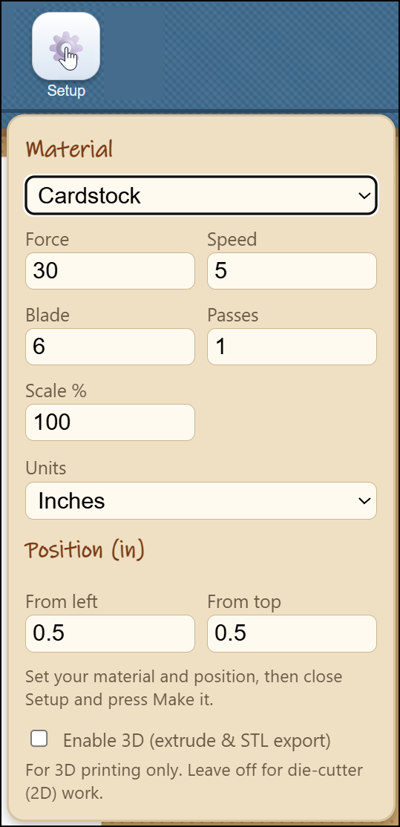
Figure 15. The Setup menu can be
used to adjust the material settings.
  - For a print-and-cut (a full-color picture, or a collage of colored pieces, printed and then cut out):
- Turn registration Marks on,
- Select Print to print the artwork with three registration marks (small targets the die cutter reads to line itself up),
- Load the carrier sheet into the die cutter,
- Then select Make It!
A sensor in the tool head of the die cutter will use the registration marks printed on the page to locate the position of the artwork and cut exactly around the areas designated by cut lines.
A collage made from colored pieces is cut this way in a single pass. Give each piece a paper color, arrange them on the page, and Print: every piece prints in its color on one sheet of white cardstock. Make It! then cuts every outline at once, so the pieces need not be cut one color at a time. Because the color is printed rather than cut from colored card, the cut edge shows the white core of the sheet.

13. Saving the Design
The Save button (the disk icon, between Connect and Open) opens a small menu with two ways to keep a design. They serve different purposes, so it is worth knowing which to reach for.
- Save project writes a .project file that reopens the design exactly as it is now. It remembers everything — whether the work is in 2D or 3D mode, the Force, Speed, Blade, and other settings, how shapes are grouped, and any solid parts that have been baked together in 3D. It also keeps a reference photo and an in-progress trace, so a half-finished tracing job reopens right where it was left. This is the file to save while a design is still being worked on.
- Save as SVG writes an interchange file — the common drawing format that other programs read, such as TinkerCAD or the die cutter's own tools. Its geometry is re-sampled when the file is reopened, which makes it a fine file to hand to another program but a lossy one to reload and keep editing. When the design needs to travel outside Sangala Studio, this is the file to send.
A reference photo is treated differently by the two choices:
- Save as SVG does not store a photo opened only as a reference for tracing; the SVG carries the finished outlines alone.
- Save project keeps the reference photo together with the in-progress trace, so the picture and the tracing sliders reopen as they were.
- Once the background of a shape has been removed to create a silhouette outline (or it has been cropped to a shape), the picture is no longer just a reference — it becomes part of the print-and-cut design. Either save keeps it, and it reappears when the file is reopened.
A third file action lives on its own button, not in the Save menu. In 3D mode an Export STL button (the blue diamond) writes an STL file — the file a 3D printer reads. It appears only in 3D mode and is covered with the rest of the 3D workflow in Section 14. In short: Save project keeps the exact design to open again in Sangala Studio, Save as SVG hands the outlines to another program, and Export STL produces the file a 3D printer prints.

14. Designing in 3D
Sangala Studio has a full three-dimensional mode for objects made on a 3D printer, which builds a solid object up in thin layers of plastic rather than tracing a flat outline with the die cutter. Everything in the earlier sections — drawing shapes, tracing a photo, combining and aligning — still applies; 3D mode adds height, so a drawn outline becomes a solid you can hold. A design made in 3D is exported as an STL file, the file a 3D printer reads, to be printed. It can also be saved as a project so that it reopens exactly as it was left, in 3D mode and with its settings (Section 13). The STL is the file that prints the object; the project is the file that keeps the design.

Switching to 3D
The button at the top right, next to the logo, switches between 2D and 3D. It reads 2D for die-cutter work; pressing it changes the label to 3D.
Because a 3D design is printed rather than cut, entering 3D hides the die-cutter controls that no longer apply: the Fabricate heading and the green Make It! button, the Material heading and its selector, the progress bar beneath them, and Simplify Nodes (an edit meant for a flat cut outline). The die-cutter connection message is not shown either. In their place, three controls appear that stay hidden in 2D: the Brick tool in the Tools Palette, and the 3D View and Export STL buttons near the top. Switching back to 2D restores the die-cutter controls.
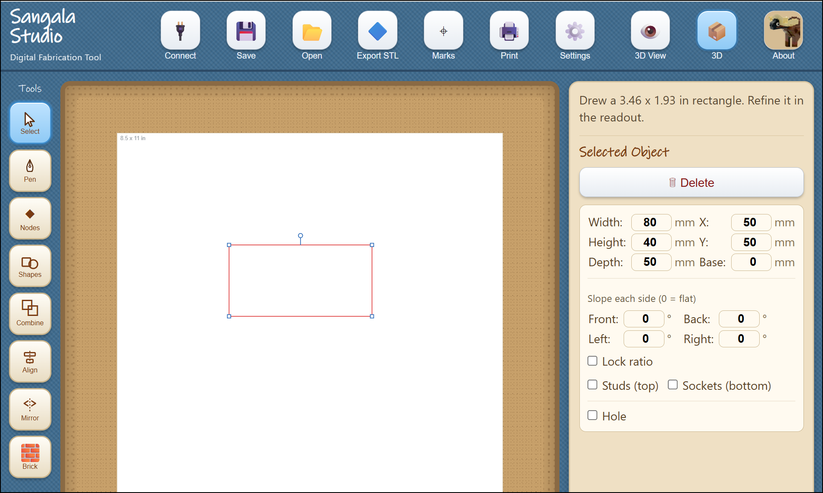
Figure 16. Switching to 3D mode reveals the Brick tool, the 3D View,
and Export STL, and adds depth controls for 3D objects.

Giving a shape depth
A flat shape becomes a solid when it is given a height. Any drawn shape can be raised — a rectangle, a circle, or a free-form outline drawn with the Pen — so that a circle becomes a cylinder and a rectangle becomes a box. The sides rise straight and the top stays level; a sloping top is set separately, below. Select a shape and the Selected object panel shows two further measurements:
- Depth — how tall the object stands, the distance the flat shape is raised to form a solid.
- Base — how far the object sits above the printer bed. A Base of zero rests the object on the bed; a larger Base lifts it, which is useful when one part is meant to rest on top of another.
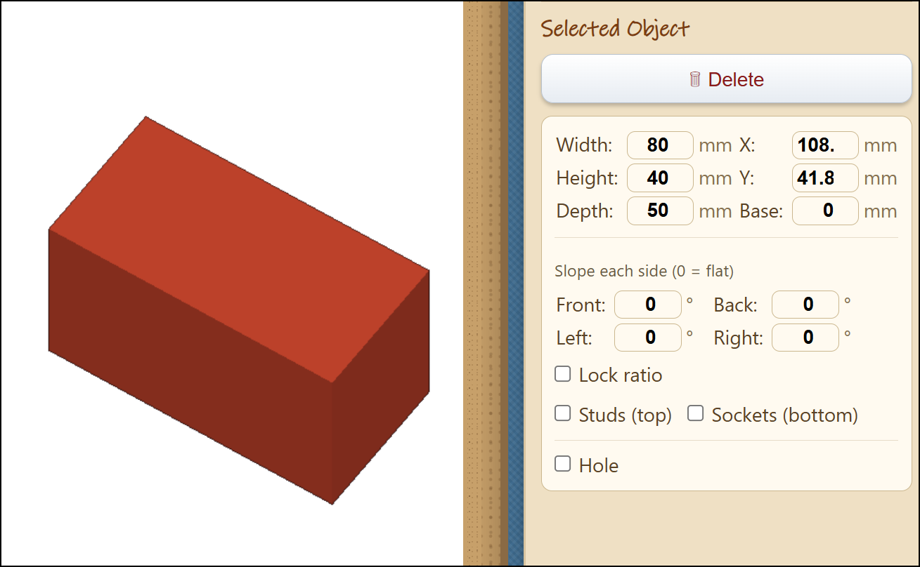
Figure 17. A rectangle selected in 3D, with the Selected Object panel showing its Depth and Base.

Sloping a top
A level top can be made to slope, so an ordinary block becomes the back of an animal or the pitch of a roof. Slope is set one side at a time, by angle. With a shape selected in 3D, the panel shows a Slope each side group: a rectangle gets four fields named Front, Right, Back, and Left; any other convex shape gets numbered fields, Side 1 through Side N. Each angle is measured from vertical, so 0 leaves that side a straight, upright wall, and a larger angle ramps that side of the top inward. Focusing a Slope field highlights the matching edge in green on the plan, so it is clear which side each number controls.
Because each side is independent, the same control builds several roof shapes:
- Slope one opposite pair of sides and the top narrows to a ridge, like the gable of a house.
- Slope every side and the top can collapse to a single point — an apex, giving a pyramid or a hip roof.
- Keep the angles small and the top stays broad and flat, with only its edges beveled.
A circle has no sides to name, so instead of the per-side fields it shows one Cone taper field. Zero leaves a straight cylinder; a moderate taper draws the rim in to a truncated cone, and a steep one brings it to a point for a full cone.
Once any side is sloped — or a circle is given a cone taper — an Invert checkbox appears. Invert mirrors the slope in Z: the top stays full and flat while the underside falls away instead. This is the shape that fills the underside of an overhang, the counterpart another part rests against.
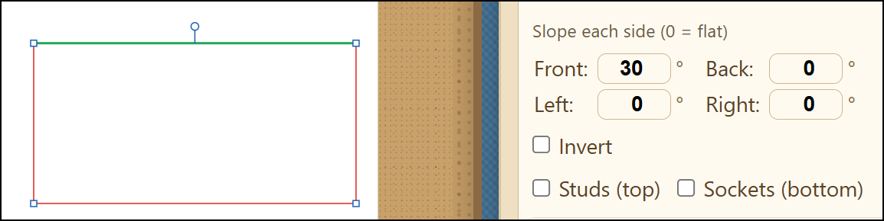
Figure 18. The per-side Slope fields (Front, Right, Back, Left)
with one edge highlighted in green on the plan, and the Invert checkbox.

The Brick tool
The Brick tool places a construction brick with studs on top. Once a brick is selected, the Brick size panel adjusts it:
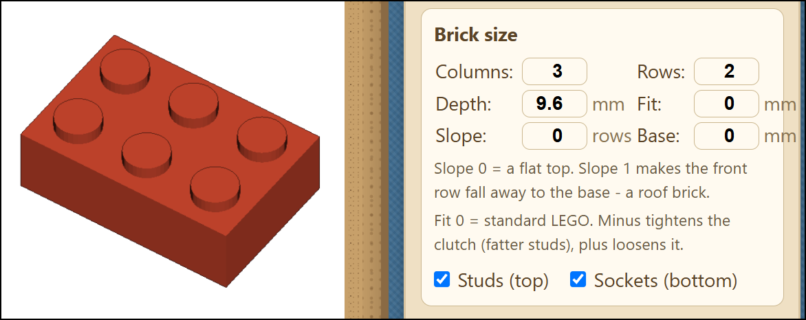
Figure 19. The Brick tool and its Brick size panel: Columns, Rows, Depth, Fit,
Slope, and Base, with the Studs, Sockets, and Inverted checkboxes.
- Columns and Rows set how many studs the brick has across and deep. A brick of one column and one row, given a large Depth, becomes a tall, narrow post — for example, a leg.
- Depth sets the brick's height.
- Fit adjusts how tightly two printed bricks snap together. Zero is the standard LEGO size. A minus value tightens the grip by making the studs slightly fatter; a plus value loosens it. Printers differ, so if new bricks feel loose, try -0.2 first and adjust in small steps.
- Studs (top), turned off, leaves the top smooth — suited to a surface such as a wing that should carry no studs.
- Sockets (bottom), turned off, closes the underside with a flat base — suited to a part that is glued to a surface rather than pressed onto studs.
- Slope ramps the top of the brick down over the number of stud rows given, leaving a roof-shaped brick. Zero is a flat top.
- Inverted, offered once a Slope is set, turns the wedge upside down: the top stays flat and keeps its studs while the underside falls away.
- Base lifts the brick above the printer bed, so one brick can sit on top of another. Zero rests it on the bed.
The brick's own Slope and Inverted controls are separate from the per-side Slope described above, and work as they always have.

Previewing in 3D
The 3D View button shows the object as a rotatable model. Dragging rotates the model and the scroll wheel zooms, so it can be turned to inspect its underside. A Show the build plate checkbox, which appears while the 3D View is open and begins unchecked, adds the Bambu A1 Mini bed beneath the object; the object then appears at true size against the printer, and the Base value reads as the gap between the object and the bed. Pressing 3D View again returns to editing.
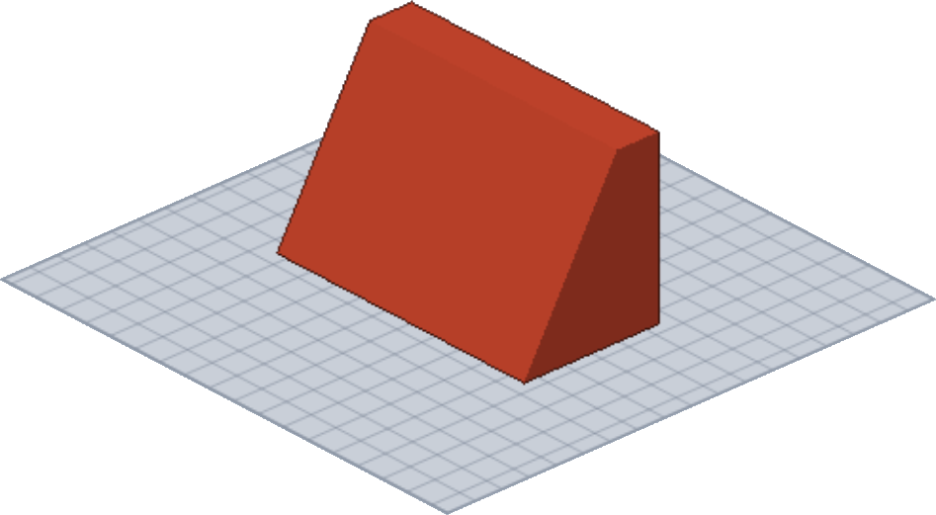
Figure 20. The 3D View, showing a rotatable model resting on the build plate.

Marking a Shape as a Hole
In 3D, a shape need not only add material — it can also take material away. Every 3D shape, bar, or baked part has a Hole toggle in its details. Left unchecked, the shape is an ordinary solid. Checked, it becomes a hole: it is drawn as a blue dotted outline, and instead of adding material it carves a void out of any solid it is grouped or combined with. A hole on its own makes nothing — it needs a solid to cut into. Marking a shape as a hole is how a window, a socket, or a bored channel is made, and it is the key to combining in 3D, described below.
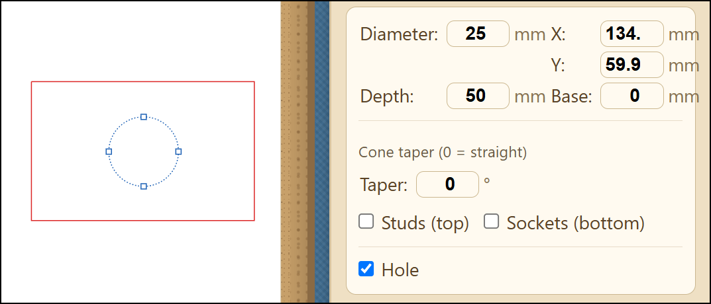
Figure 21. A shape with the Hole toggle checked, drawn as a blue dotted outline over a solid.
When the combined shape is rendered in the 3D Viewer, this is the result.
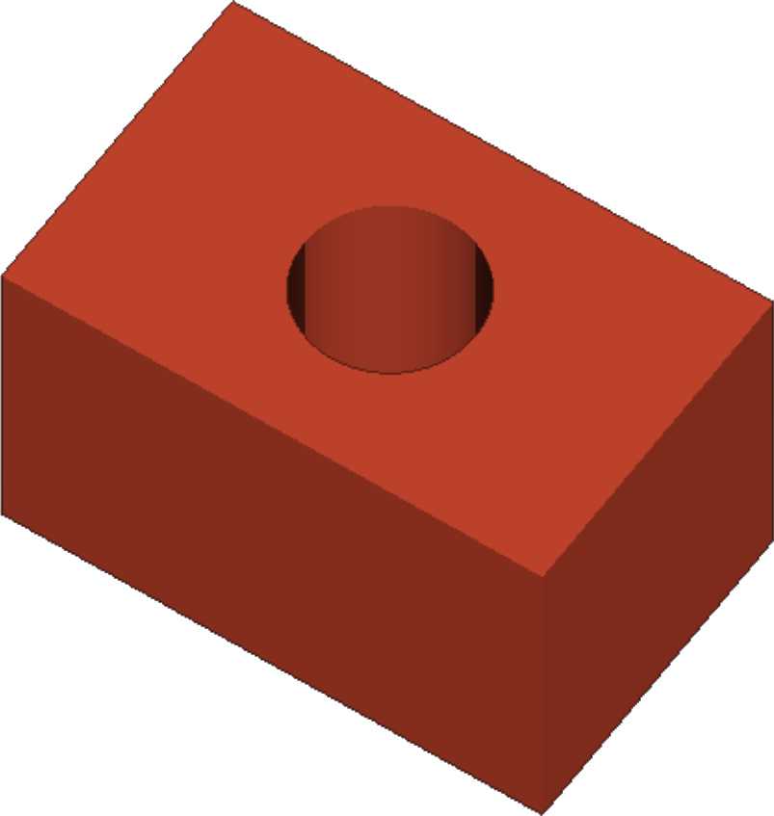
Figure 22. The effect of combining a hole with a solid rendered in the 3D Viewer.

3D bars
A straight line, which cuts or creases in 2D, can become a solid rod in 3D. Draw a Line (from the Shapes menu), select it in 3D, and turn on its 3D bar toggle. The bar runs along the line at the Base height, and the line's position and angle place and aim it — so a line laid across a part and lifted to the right Base passes a rod straight through it. Choose the cross-section in the panel: round, set by Diameter, or rectangle, set by Height and Width. A bar is a 3D object with no meaning to the flat die cutter, so it is never cut; on the plan it is drawn in teal, distinct from a red cut line or a blue dashed fold.
A bar earns its place when combined with a part. Mark it a Hole and it bores a channel — an axle hole through a wall. Leave it solid and it adds a peg. Either way, select the bar together with the part and Combine, below.
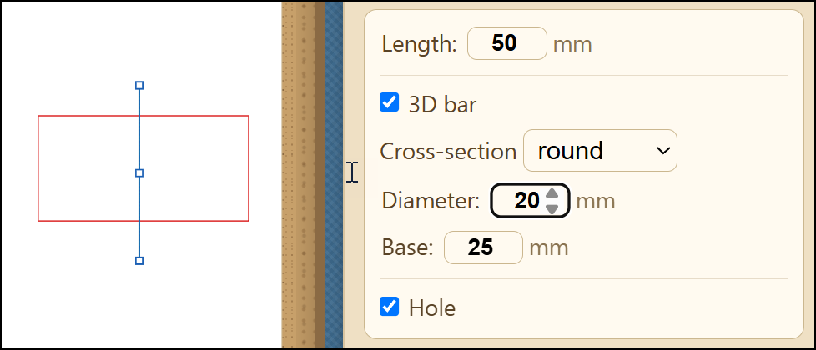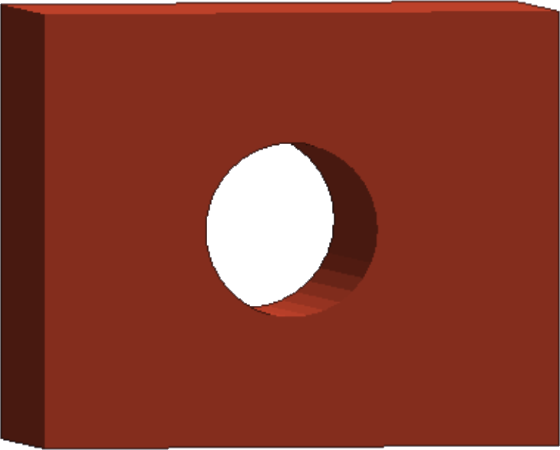
Figure 23. A line turned into a 3D bar, shown teal on the plan (left)
and as a round rod through a block in the 3D View (right).

Grouping pieces
Group and Ungroup (the buttons in the details panel) bundle pieces so they move and select as one. Grouping does not weld the pieces together and does not change their geometry: each grouped solid keeps its own shape and its own color in the 3D View, and Ungroup takes them apart again. Grouping is a way to handle several pieces as a unit while you arrange them, not a way to merge them.
To group, select two or more pieces — draw a box around them, or click one and Shift+click another — then press Group. Groups nest: to add a piece to an existing group, select the group, Shift+click the new piece, and Group again. Ungroup peels off one level at a time, so a group built up in steps comes apart in the same steps.
Grouped solids that touch still print as one object, because the printer's slicing software joins overlapping plastic on its own. To merge pieces into a single welded part inside Sangala Studio — one shape with one surface — use Combine instead.
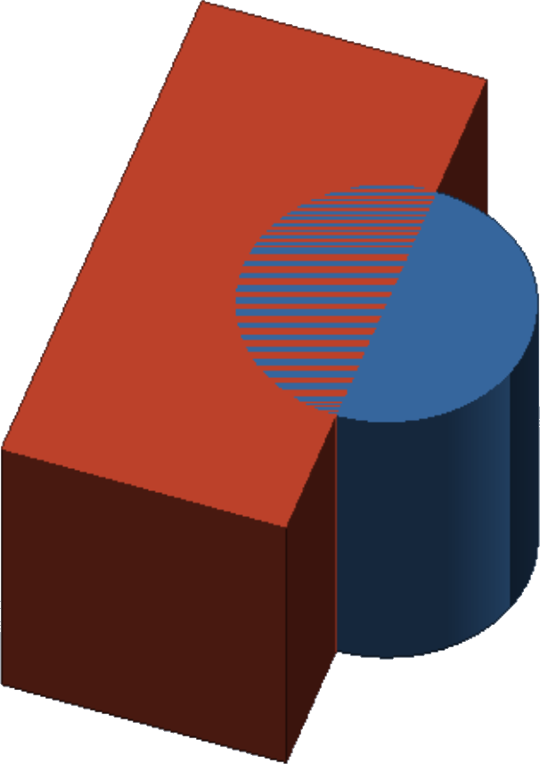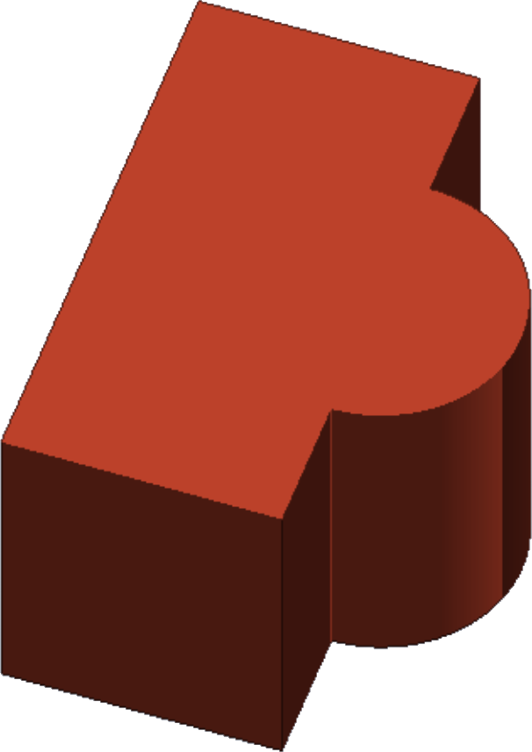
Figure 24. Two shapes selected and grouped. The shapes on the left have not been combined and
are shown in separate colors. The shapes on the right have been combined and are one color.

Combining in 3D
Combine (the overlapping-squares icon, described for flat shapes in Section 8) does far more in 3D: it runs a true three-dimensional boolean and bakes the result into a single solid part. Select two or more 3D solids — shapes with Depth, 3D bars, or parts already baked from an earlier Combine — and the Combine menu offers two operations:
- Union — merge the pieces into one solid. Union also honors the Hole flag: any solid in the selection is added, and any Hole is carved away, so a single Union both merges the solids and cuts the holes.
- Intersect — keep only the region where all the selected pieces overlap.
The 3D menu does not show Difference, because carving is done with a Hole: mark the cutting shape a Hole and Union it. Any number of pieces can be combined at once, not just two. If a selected shape is still flat, Combine asks for a Depth first, since a flat shape is not yet a solid.
The result is one baked part. It saves and reopens exactly, steps back and forward through Undo and Redo, and can be moved, rotated, and resized like any shape; its details panel gives it its own Depth and Base. With the 3D View off, a part that was carved shows its openings as dashed lines on the plan, so a hole stays visible even in the flat view. This baking is what sets Combine apart from Group: Group bundles pieces that stay separate, while Combine welds them into one committed part.

Seeing a hole before you combine
Combine bakes a result that is not easily adjusted afterward, so it helps to check the fit first. Grouping a solid with a Hole gives a live preview: the moment the two are grouped, the 3D View shows the void carved out, without baking anything. You can nudge the Hole, rotate the model, and confirm the cut lands where you want it. The pieces stay separate and Ungroup-able the whole time, and the same carved shape is what the STL exports — so a grouped solid and Hole prints as a solid with a hole even before you Combine. When the fit is right, Combine bakes it into the single committed part.

Building a curved, tapering part
A tail, a horn, a leg, or a trunk is built as a stack of circles, each one a little lower and a little smaller than the one above. A circle becomes a cylinder, and Base sets how high off the printer bed it sits, so the stack hangs one piece beneath the next. Group the stack to move it as one while you shape it — the touching cylinders still print as a single solid because the slicer joins them — or Combine with Union to bake it into one welded part. Three things decide whether it reads as the shape it is meant to be:
- Curve by turning, not by sliding. Moving each circle sideways by the same amount gives a straight diagonal, however large the steps, and the part leans rather than curves. What the eye reads as a curve is a change of direction, so turn the part instead: start it at an angle where it meets the body and bring it steadily upright by the tip. A tail that leaves the rump about 65 degrees off vertical and finishes hanging straight down turns through some 60 degrees, which cannot be mistaken for a lean.
- Taper without reversing. Make every circle smaller than the one above it, all the way down. A part that narrows and then widens again reads as no taper at all, and about two and a half to one, root to tip, is enough to see. A tuft at the end of a tail may flare back out, as it does on the real animal, as long as it stays clearly narrower than the root.
- Swing it across the view. The 3D View looks down on the model at an angle, so a part curving toward the viewer has its bend pointing almost at the camera, where it flattens to nearly nothing — the curve is real and still looks straight. Curving it across the view spends the movement where it can be seen.
Position has the same trap: a part tucked inside the footprint of the body it hangs from is hidden underneath it. A part that is built correctly and cannot be seen looks exactly like a broken one, so build it, then rotate the model and check. For printing, keep the thinnest section at about 3.5 mm or more, since anything finer snaps in handling, and a part that hangs in free air needs support material turned on. If that proves troublesome, the sturdier answer is to draw it into the body outline with the Pen, so that it becomes one closed shape with the body, prints flat, and cannot break off.
The sample file Buffalo Tail (fused and unfused).svg is a worked example: the same tail built twice. On one side the stack is left as separate, grouped cylinders, and each shows in its own color in the 3D View; on the other the stack has been Combined into one part, which reads as a single color. That change of color is the quick sign of whether a stack has been baked into one piece with Combine or is still a bundle of separate ones.

Saving for the printer
Export STL (the diamond icon, shown only in 3D mode) writes an STL file, which is then opened in the printer's own software (Bambu Studio) to print the object. With nothing selected, it exports the whole model — every piece together — as one file. To save a single piece on its own, select it first and then Export STL; you can select several pieces to export just those. Export STL is a separate button, not one of the choices in the Save menu (Section 13): the Save menu keeps your design, while Export STL produces the file the printer reads.

15. Quick Reference

Tool | Action
Move or resize a shape | Select, then drag the shape or a corner
Draw a rectangle or circle | Shapes, Rectangle or Circle, then drag
Draw a free-form outline | Pen, click each point, Enter to finish
Carry on from a loose end | Pen, click the end of the outline
Reshape an outline | Nodes, then drag, add, or delete points
Make a line fold instead of cut | Select it, click Fold
Join, subtract, or overlap two shapes | Combine, then Union, Difference, or Intersect (in 3D, Union or Intersect only)
Center one shape in another | Select both, Align, Center
Cut a subject out of a photo | Open the photo, Remove BG, Confirm
Crop a photo to a circle or shape | Draw the shape, then Combine, Intersect
Print, then cut on the print | Marks on, Print, Make It!
Rotate a shape | Select it, then drag the round handle above it
Nudge a shape a small distance | Select it, then press an arrow key (Shift for 1 mm)
Fill a shape with a paper color | Select it, then click a color in the Selected object panel
Change which shape is in front | Select it, then Back, Lower, Raise or Front
Undo or redo a change | Ctrl-Z undoes; Ctrl-Y redoes
Draw with Snap!'s turtle | Snap!, send pen trails to Sangala
Draw a straight line | Shapes, Line; Fold makes it a crease
Add a glue tab to a shape | Shapes, Tab, then drag along the shape's edge
Break a shape apart at a node | Nodes, click a node, Break at Node
Duplicate a shape | Ctrl-C copies; Ctrl-V pastes a copy
Mirror a shape or an assembly | Select it, Mirror, Flip Horizontal or Flip Vertical
Turn Snap to Fit on or off | The magnet button beside the zoom controls
Save a project that reopens exactly | Save, then Save project
Save an SVG for TinkerCAD or the die cutter | Save, then Save as SVG
Export an STL for 3D printing | Export STL (shown in 3D mode)
Cut a second or further window into a shape | Combine, Difference, again for each window
Mark a shape as a hole to carve (3D) | Select it, check Hole in its details
Turn a line into a 3D bar | Draw a line in 3D, check 3D bar in its details
Bundle pieces to move together (3D) | Select them, Group; Ungroup peels one level

16. Tool Sequences for Specific Designs
- A Single Silhouette — Open a photo, Remove BG, Confirm, then cut. Tidy the outline with Simplify nodes or the Node editing tool.
- A Collage — Draw or trace each shape, use the Shapes and Pen tools, and Align to position them. Cut each shape separately on a different color of cardstock (for simple silhouettes) and place the cut-out shapes by hand to form a collage.
- A Shadowbox Frame — Draw a square and a circle with Shapes, use Align Center to place the window, add folding tabs, and set the fold lines to Fold so the die cutter cuts them as a dashed fold line instead of cutting all the way through.

